DSA 0601 - Data handling and visualization
Set 12 - Website Traffic

Name : B.Jahnavi
Reg.no:192325043

- Line Chart for Daily Page Views
Code:

library(ggplot2)

traffic <- data.frame(
Date = as.Date(c("2023-01-01", "2023-01-02", "2023-01-03")),
Page_Views = c(1500, 1600, 1400),
Click_Through_Rate = c(2.3, 2.7, 2.0)
)

ggplot(traffic, aes(x = Date, y = Page_Views)) +
geom_line(linewidth = 1) +
geom_point(size = 3) +
geom_text(
aes(label = Page_Views),
vjust = -0.7
) +
labs(
title = "Daily Website Page Views",
x = "Date",
y = "Page Views"
) +
theme_minimal()

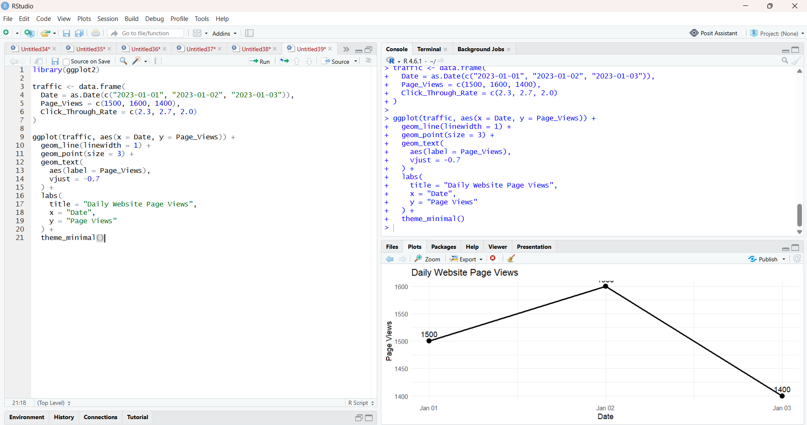

- Bar Chart for Top N Days by Click-Through Rate
Code:

library(ggplot2)

traffic <- data.frame(
Date = as.Date(c("2023-01-01", "2023-01-02", "2023-01-03")),
Page_Views = c(1500, 1600, 1400),
Click_Through_Rate = c(2.3, 2.7, 2.0)
)

N <- 3

top_days <- traffic[
order(-traffic$Click_Through_Rate),
][1:N, ]

ggplot(
top_days,
aes(
x = reorder(as.character(Date), Click_Through_Rate),
y = Click_Through_Rate
)
) +
geom_bar(stat = "identity") +
geom_text(
aes(label = paste0(Click_Through_Rate, "%")),
vjust = -0.5
) +
labs(
title = "Top Days by Click-Through Rate",
x = "Date",
y = "Click-Through Rate (%)"
) +
theme_minimal()

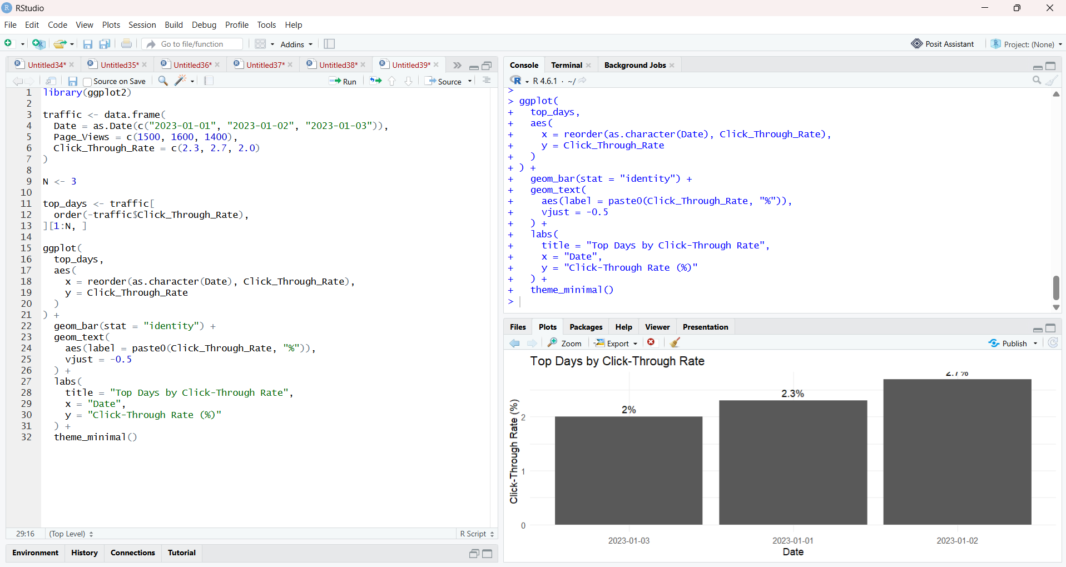

- Table of Website Traffic Data
Code:

traffic <- data.frame(
Date = as.Date(c("2023-01-01", "2023-01-02", "2023-01-03")),
Page_Views = c(1500, 1600, 1400),
Click_Through_Rate = c(2.3, 2.7, 2.0)
)

print(traffic)

library(knitr)

kable(
traffic,
caption = "Website Traffic Data",
col.names = c("Date", "Page Views", "Click-Through Rate (%)")
)

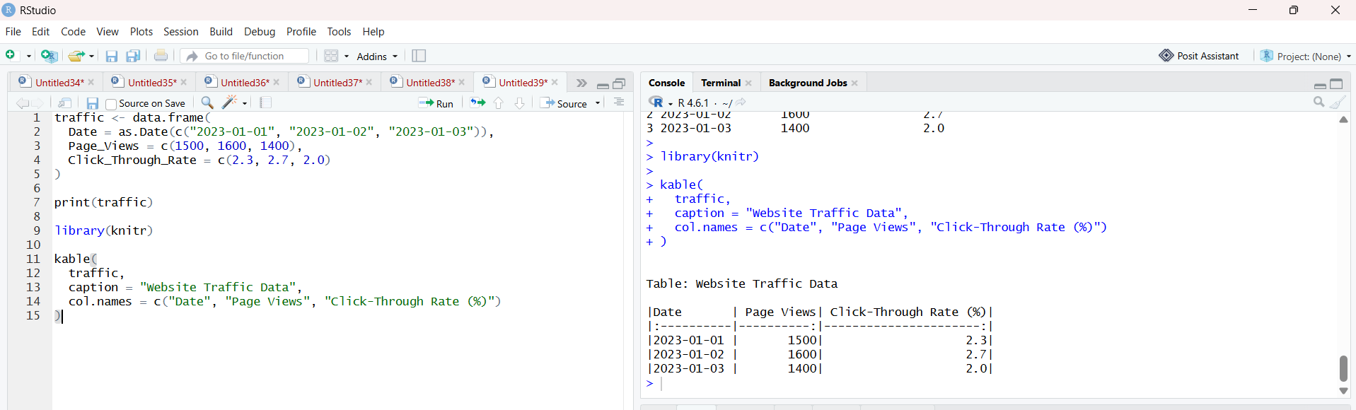

- Prepare Data for Tableau Dashboard
Code:

traffic <- data.frame(
Date = as.Date(c("2023-01-01", "2023-01-02", "2023-01-03")),
Page_Views = c(1500, 1600, 1400),
Click_Through_Rate = c(2.3, 2.7, 2.0)
)

write.csv(
traffic,
"website_traffic.csv",
row.names = FALSE
)

print("CSV file created successfully.")

